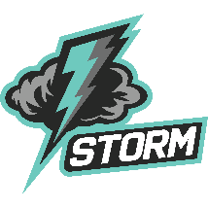 | Carlos E. Haile Middle School  School Advisory Committee Meeting  Friday, January 26, 2024 |  | Convener: Ms. Wood  Media Center and TEAMS
Mission Statement
We will inspire our students with a passion for learning, empowering them to pursue their dreams confidently and creatively while contributing to our community, nation and world.

- Call to Order  - Establish Quorum for Voting Members  - Review of A+ Recognition Plan  - Vote to Approve A+ Recognition Plan  - Adjournment |  | PROTOCOLS:  - Be on time and participate fully.  - Respect the opinions of others.  - Ask questions and offer opinions.  - Take care of yourself.  - No “side bar” conversations.

